Table 1: Census data description, year 2010

|  |  |  |
| --- | --- | --- |
| **Geographic characteristics** | **Total populated census blocks** | 6,182,882 |
| **Total census-designated urban areas** | 3,590,278 (58%) |
| **Demographic characteristics** | **Total population** | 306,675,006 |
| **Total population of children (birth – 18)** | 73,690,271 (24%) |
| **Mean (range) number of children in census blocks** | 12 (0-2214) |
| **Population of children by living location** | **Rural** | 13,763,183 (19%) |
| **Urban clusters (≥2,500 and <50,000 people)** | 6,994,464 (9%) |
| **Urbanized area (≥50,000 people)** | 52,932,624 (72%) |
| **Population of children by median household income** | **<$20,000** | 2,614,804 (4%) |
| **$20,000 to <$35,000** | 12,770,843 (17%) |
| **$35,000 to <$50,000** | 18,573,954 (25%) |
| **$50,000 to <$75,000** | 21,953,876 (30%) |
| **≥$75,000** | 17,763,239 (24%) |

Table 2: NO2 concentrations (ug/m3) by strata

|  |  |  |  |  |  |  |  |
| --- | --- | --- | --- | --- | --- | --- | --- |
|  |  | **Mean** | **Min** | **25%** | **Median** | **75%** | **Max** |
| **Total** |  | 13.2 | 1.5 | 7.9 | 11.4 | 16.6 | 58.3 |
| **By living location** | **Rural** | 8.0 | 1.5 | 6.0 | 7.8 | 9.8 | 37.7 |
| **Urban cluster** | 12.0 | 1.6 | 9.6 | 11.9 | 14.2 | 35.6 |
| **Urbanized area** | 18.4 | 2.6 | 13.0 | 17.0 | 22.1 | 58.3 |
| **By median household income** | **<$20,000** | 16.1 | 2.0 | 10.4 | 14.9 | 20.1 | 56.8 |
| **$20,000 to <$35,000** | 13.2 | 1.6 | 8.1 | 11.7 | 16.7 | 58.3 |
| **$35,000 to <$50,000** | 11.8 | 1.5 | 7.0 | 10.0 | 14.5 | 58.0 |
| **$50,000 to <$75,000** | 12.8 | 1.6 | 7.6 | 10.8 | 15.7 | 55.7 |
| **≥$75,000** | 16.5 | 2.1 | 10.9 | 14.9 | 20.6 | 55.5 |

Table 3: Childhood asthma survey summaries

|  |  |  |  |  |  |  |
| --- | --- | --- | --- | --- | --- | --- |
|  | **2006** | **2007** | **2008** | **2009** | **2010** | **Total** |
| **BRFSS sample (w)** | 55,094 (50,674,742) | 59,487 (43,661,381) | 61,862 (53,327,550) | 59,821 (47,747,373) | 57,200 (39,975,264) | 293,464 |
| **Ever asthma sample (w)** | 7,168 (6,493,224) | 7,971 (5,763,409) | 8,255 (7,218,400) | 8,126 (6,279,938) | 7,483 (5,158,455) | 39,003 |
| **ACBS Sample (w)** | 2,017 (4,580,870) | 2,797 (5,459,638) | 3,924 (4,343,245) | 4,095 (4,154,076) | 2,196 (3,116,669) | 16,156 |
| **Incident case sample (w)** | 154 (404,276) | 173 (312,917) | 169 (385,818) | 153 (297,546) | 160 (319,743) | 809 |
| **At-risk sample (w)** | 48,080 (30,825,589) | 51,689 (36,050,557) | 53,776 (26,491,259) | 51,848 (25,942,087) | 49,877 (22,900,850) | 255,270 |
| **Incidence rate** | 13.1 | 8.7 | 14.6 | 11.5 | 14.0 | 11.6* |
| **Prevalence rate** | 12.8 | 13.2 | 13.5 | 13.2 | 12.9 | 13.1** |
| **Number of states in** | 18 | 26 | 20 | 17 | 17 | 32*** |

*\*Aggregate asthma incidence rate per 1,000 at-risk children*

*\*\*Aggregate asthma prevalence rate per 100 children*

*\*\*Total number of states included in the aggregate asthma incidence rate estimation*

Table 4: Comparing results of the burden of disease using state-specific estimates vs original estimates

|  |  |  |  |  |  |  |  |  |  |  |  |  |  |  |
| --- | --- | --- | --- | --- | --- | --- | --- | --- | --- | --- | --- | --- | --- | --- |
|  |  | **Results using flat national-level IR** | | | **Results using state-specific IR** | | | | **Difference** | | | **Difference (%)** | | |
|  |  | **Incident cases** | **AC** | **AF** | **Incident cases** | **AC** | **AF** | **Incident cases** | | **AC** | **AF** | **Incident cases** | **AC** | **AF** |
|  | **Total** | 794,934 | 141,931 | 17.9% | 747,437 | 131,739 | 17.6% | -47,497 | | -10,192 | -0.3% | -6.0% | -7.2% | -1.7% |
| **By living location (% of Total)** | **Rural** | 148,470 (19%) | 14,466 (10%) | 9.7% | 140,799 (19%) | 13,788 (10%) | 9.8% | -7,671 | | -678 | 0.1% | -5.2% | -4.7% | 1.0% |
| **Urban cluster** | 75,453 (9%) | 9,844 (7%) | 13.0% | 70,524 (9%) | 9,206 (7%) | 13.1% | -4,929 | | -638 | 0.1% | -6.5% | -6.5% | 0.8% |
| **Urbanized area** | 571,011 (72%) | 117,621 (83%) | 20.6% | 536,113 (72%) | 108,745 (83%) | 20.3% | -34,898 | | -8,876 | -0.3% | -6.1% | -7.5% | -1.5% |
| **By median household income (% of Total)** | **<$20,000** | 28,207 (4%) | 5,892 (4%) | 20.9% | 27,770 (4%) | 5,786 (4%) | 20.8% | -437 | | -106 | -0.1% | -1.5% | -1.8% | -0.5% |
| **$20,000 to <$35,000** | 137,765 (17%) | 25,794 (18%) | 18.7% | 132,843 (18%) | 24,699 (19%) | 18.6% | -4,922 | | -1,095 | -0.1% | -3.6% | -4.2% | -0.5% |
| **$35,000 to <$50,000** | 200,367 (25%) | 34,549 (24%) | 17.2% | 188,466 (25%) | 32,088 (24%) | 17.0% | -11,901 | | -2,461 | -0.2% | -5.9% | -7.1% | -1.2% |
| **$50,000 to <$75,000** | 236,827 (30%) | 40,540 (29%) | 17.1% | 221,334 (30%) | 37,253 (28%) | 16.8% | -15,493 | | -3,287 | -0.3% | -6.5% | -8.1% | -1.8% |
| **≥$75,000** | 191,621 (24%) | 35,128 (25%) | 18.3% | 176,880 (24%) | 31,885 (24%) | 18.0% | -14,741 | | -3,243 | -0.3% | -7.7% | -9.2% | -1.6% |

Figure 1: Childhood asthma incidence rate estimation flow chart

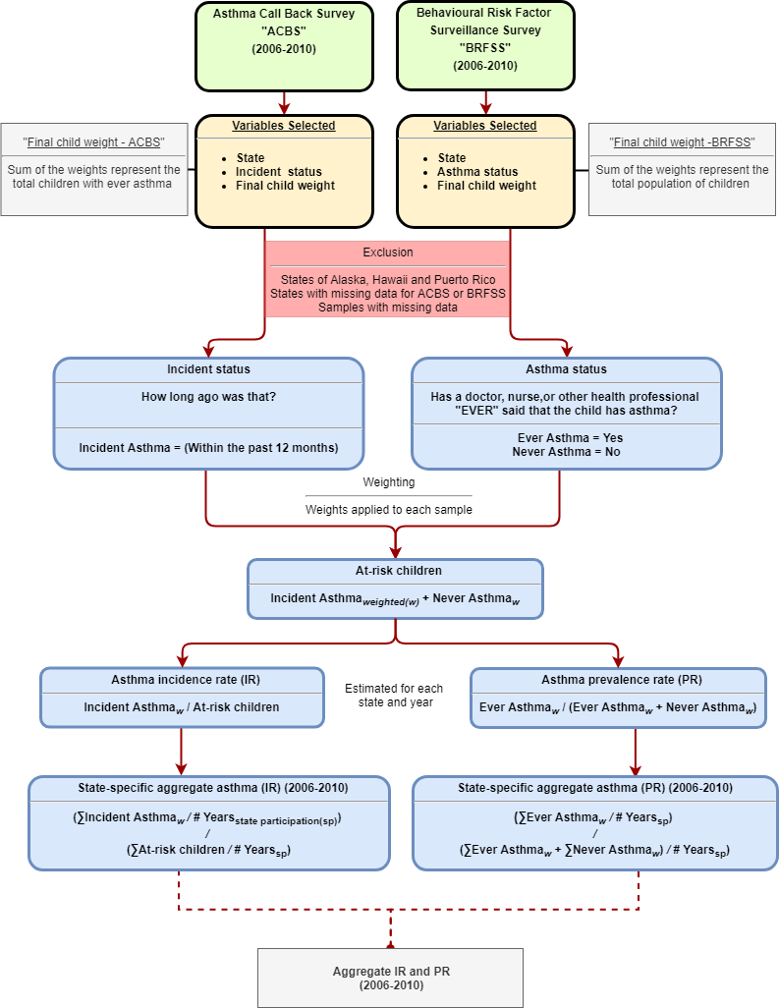

Figure 2: Attributable fraction by median household income group stratified into living location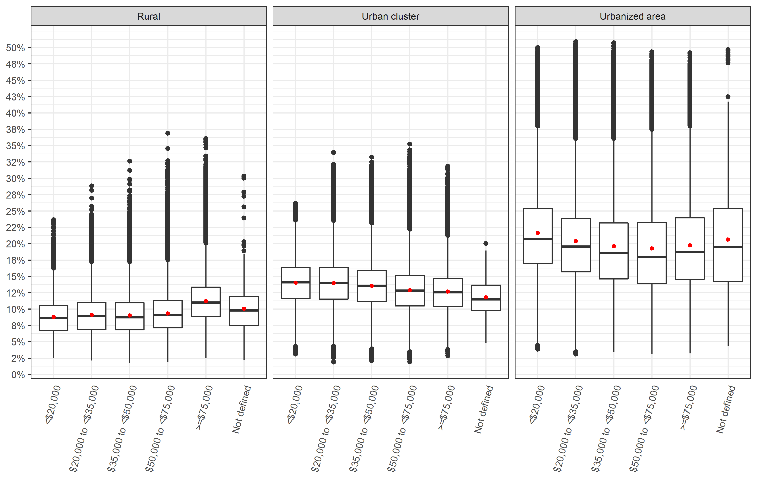

*\*Red dot represents the mean value while the midline represents the median value*

Figure 3: Attributable fraction by state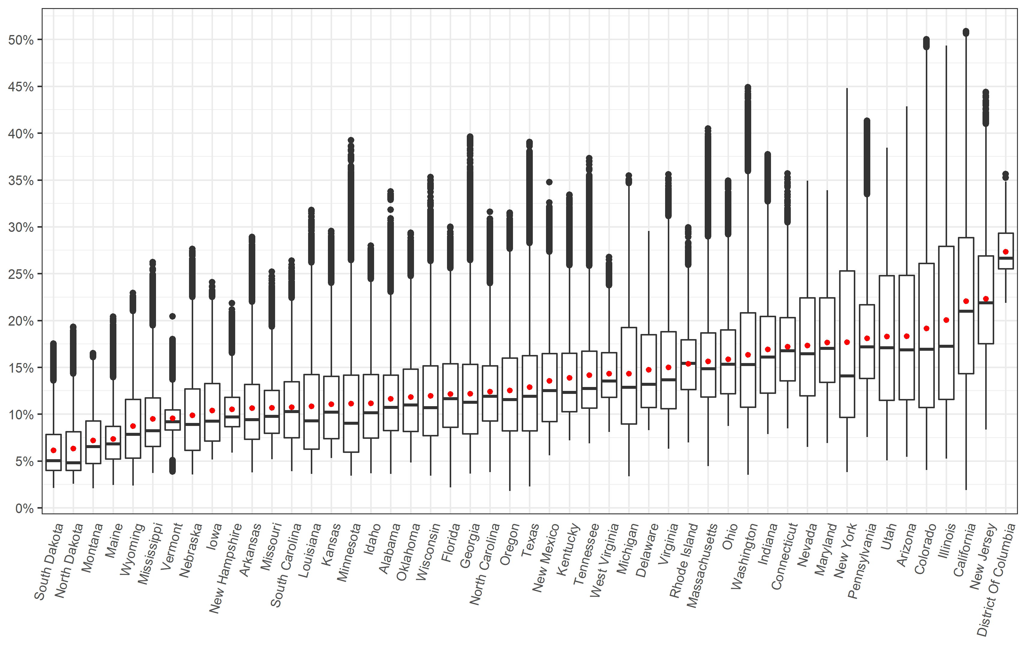

Figure 4: Attributable fraction by state and living location

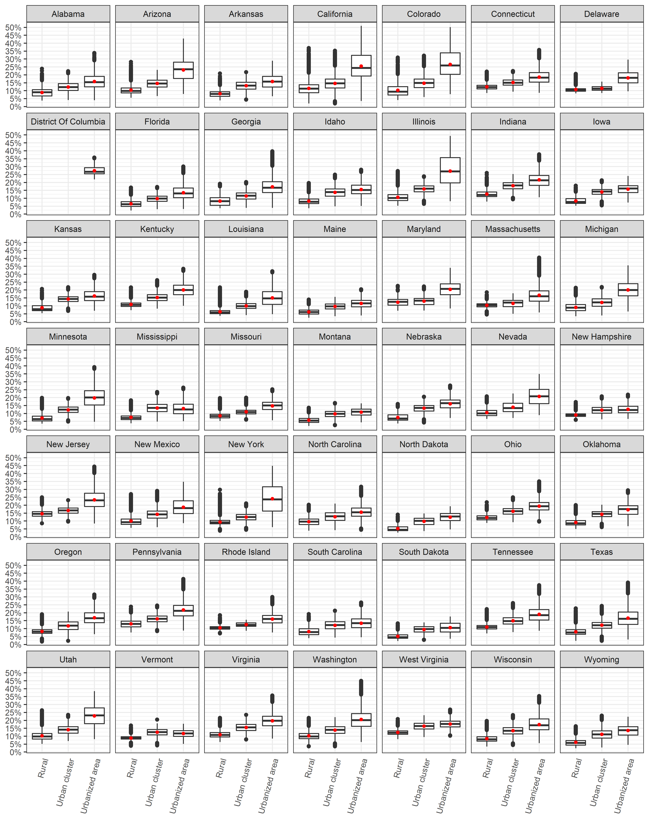

Figure 5: Attributable fraction by state and median household income group

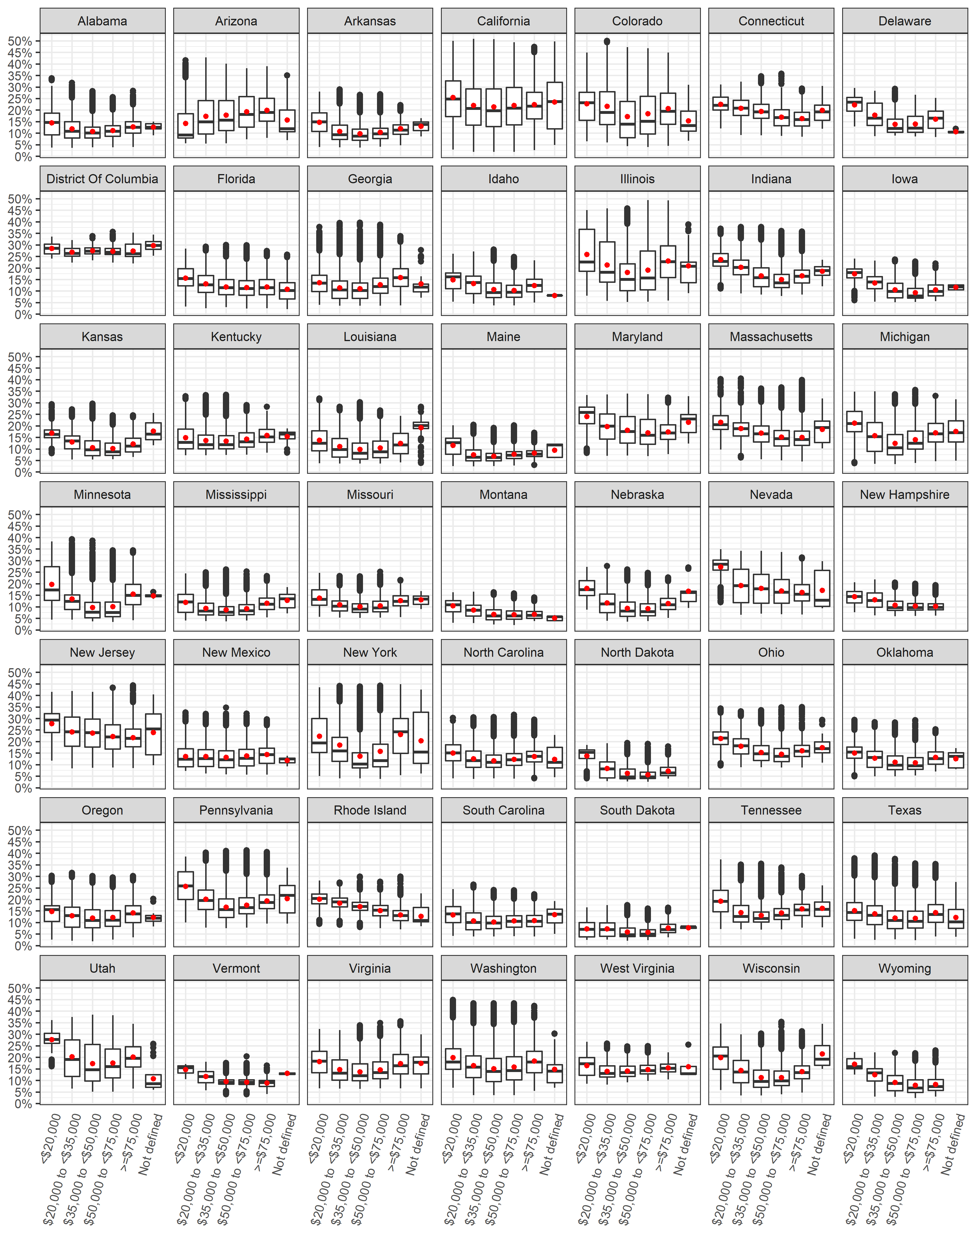

**Supplementary Material**

Table S1: Available childhood asthma incidence rates by state and year 22

Table S2: Childhood asthma survey summary by state (Total of 2006-2010) 23

Table S3: NO2 concentration (ug/m3) by state 24

Table S4: State-specific results and comparison 25

Figure S1: NO2 concentration (ug/m3) by living location 26

Figure S2: NO2 concentration (ug/m3) by median household income group 26

Figure S3: NO2 concentration (ug/m3) by living location stratified into median household income group 27

Figure S4: NO2 concentration (ug/m3) by median household income group stratified into living location 27

Figure S5: NO2 concentration (ug/m3) by state 28

Figure S6: NO2 concentration (ug/m3) by state and median household income group 29

Figure S7: NO2 concentration (ug/m3) by state and living location 30

Figure S8: Attributable Fraction by living location 31

Figure S9: Attributable Fraction by median household income group 31

Figure S10: Attributable Fraction by median household income group stratified into living location 32

Table S: Available childhood asthma incidence rates by state and year

|  |  |  |  |  |  |  |
| --- | --- | --- | --- | --- | --- | --- |
| **State** | **2006\*** | **2007\*** | **2008\*** | **2009\*** | **2010\*** | **Aggregate IR\*** |
| Alabama |  |  |  |  |  |  |
| Alaska |  |  |  |  |  |  |
| Arizona | 23.7 | 6.8 |  |  |  | 15.2 |
| Arkansas |  |  |  |  |  |  |
| California | 12.1 | 6.5 |  |  |  | 9.3 |
| Colorado |  |  |  |  |  |  |
| Connecticut |  | 9.9 | 14.1 | 10.8 | 13.5 | 12.0 |
| Delaware |  |  |  |  |  |  |
| District of Columbia | 5.3 | 28.8 |  |  |  | 17.7 |
| Florida |  |  |  |  |  |  |
| Georgia | 6.4 | 5.8 | 9.1 | 16.6 | 6.9 | 9.1 |
| Hawaii |  |  |  |  |  |  |
| Idaho |  |  |  |  |  |  |
| Illinois |  | 4.2 |  | 9.2 |  | 6.7 |
| Indiana | 25.4 | 9.3 | 13.4 | 9.9 | 17.6 | 15.2 |
| Iowa | 5.0 | 4.0 | 9.9 |  |  | 6.3 |
| Kansas | 7.8 | 9.9 | 9.9 | 8.3 | 9.0 | 9.0 |
| Kentucky |  |  |  |  |  |  |
| Louisiana |  |  |  | 5.8 |  | 5.8 |
| Maine | 13.0 | 8.7 | 5.8 |  |  | 9.2 |
| Maryland | 16.2 | 8.6 | 11.0 | 17.3 | 2.3 | 11.2 |
| Massachusetts |  |  |  |  |  |  |
| Michigan | 5.3 | 7.7 | 5.2 | 13.4 | 29.3 | 12.0 |
| Minnesota |  |  |  |  |  |  |
| Mississippi |  | 10.8 |  |  | 17.2 | 14.0 |
| Missouri | 21.2 | 10.3 | 7.2 |  |  | 12.9 |
| Montana | 2.8 | 2.0 |  | 3.7 | 8.5 | 4.3 |
| Nebraska | 11.9 | 8.3 | 8.9 | 3.3 | 12.9 | 9.1 |
| Nevada |  |  |  |  |  |  |
| New Hampshire | 11.5 | 13.8 | 10.4 |  |  | 12.0 |
| New Jersey |  |  | 6.3 | 12.5 | 10.5 | 9.8 |
| New Mexico |  | 3.2 | 9.5 |  | 7.2 | 6.7 |
| New York | 12.9 | 6.1 | 28.4 | 11.2 |  | 14.7 |
| North Carolina |  |  |  |  |  |  |
| North Dakota |  |  |  |  |  |  |
| Ohio |  | 13.1 | 17.0 |  |  | 15.1 |
| Oklahoma |  | 9.2 | 10.1 |  | 12.9 | 10.8 |
| Oregon |  | 11.1 |  |  |  | 11.1 |
| Pennsylvania |  | 21.8 |  |  | 4.3 | 13.2 |
| Rhode Island |  |  | 15.3 | 13.2 |  | 14.3 |
| South Carolina |  |  |  |  |  |  |
| South Dakota |  |  |  |  |  |  |
| Tennessee |  |  |  |  |  |  |
| Texas | 14.4 |  | 18.2 | 12.5 | 21.0 | 16.6 |
| Utah |  | 15.4 | 11.9 | 5.6 | 9.3 | 10.4 |
| Vermont | 13.5 | 4.4 | 8.5 | 21.2 | 10.4 | 11.5 |
| Virginia |  |  |  |  |  |  |
| Washington |  |  |  | 7.9 | 5.6 | 6.8 |
| West Virginia |  | 11.8 |  |  |  | 11.8 |
| Wisconsin | 12.3 |  |  |  |  | 12.3 |
| Wyoming |  |  |  |  |  |  |

*\*Incidence rate per 1,000 at-risk children*

Table S2: Childhood asthma survey summary by state (Total of 2006-2010)

|  |  |  |  |  |
| --- | --- | --- | --- | --- |
| **State** | **Total ACBS sample** | **Total BRFSS sample** | **Total ever asthma** | **Total incident cases** |
| Arizona | 103 | 5,535 | 699 | 10 |
| California | 172 | 11,801 | 1,543 | 13 |
| Connecticut | 549 | 7,112 | 1,132 | 47 |
| D.C. | 69 | 4,101 | 685 | 6 |
| Georgia | 545 | 9,433 | 1,455 | 26 |
| Illinois | 122 | 6,187 | 778 | 6 |
| Indiana | 500 | 9,824 | 1,361 | 41 |
| Iowa | 245 | 8,084 | 724 | 19 |
| Kansas | 827 | 14,699 | 1,839 | 50 |
| Louisiana | 88 | 8,829 | 1,214 | 4 |
| Maine | 376 | 4,523 | 644 | 23 |
| Maryland | 624 | 13,093 | 1,897 | 44 |
| Michigan | 680 | 10,762 | 1,524 | 43 |
| Mississippi | 208 | 10,816 | 1,527 | 14 |
| Missouri | 262 | 5,646 | 814 | 20 |
| Montana | 286 | 8,609 | 909 | 17 |
| Nebraska | 717 | 17,883 | 1,644 | 53 |
| New Hampshire | 232 | 5,285 | 664 | 19 |
| New Jersey | 458 | 15,410 | 2,230 | 32 |
| New Mexico | 287 | 5,554 | 765 | 17 |
| New York | 404 | 7,083 | 1,079 | 28 |
| Ohio | 351 | 7,989 | 1,138 | 32 |
| Oklahoma | 299 | 8,611 | 1,291 | 21 |
| Oregon | 165 | 4,793 | 579 | 13 |
| Pennsylvania | 209 | 14,760 | 2,090 | 12 |
| Rhode Island | 169 | 7,127 | 1,209 | 11 |
| Texas | 780 | 16,749 | 2,293 | 55 |
| Utah | 573 | 14,417 | 1,617 | 45 |
| Vermont | 597 | 8,784 | 1,220 | 40 |
| Washington | 594 | 9,706 | 1,165 | 33 |
| West Virginia | 85 | 5,089 | 663 | 5 |
| Wisconsin | 140 | 5,170 | 611 | 10 |

\**Incidence rate* per 1,000 at-risk children

\**Prevalence rate per 100 children*

Table S3: NO2 concentration (ug/m3) by state

|  |  |  |  |  |  |  |
| --- | --- | --- | --- | --- | --- | --- |
| **State** | **Mean** | **Min** | **25%** | **Median** | **75%** | **Max** |
| Alabama | 10.3 | 3.0 | 7.1 | 9.3 | 12.5 | 33.8 |
| Arizona | 17.0 | 4.6 | 10.1 | 15.1 | 23.4 | 45.9 |
| Arkansas | 9.3 | 3.2 | 6.2 | 8.1 | 11.6 | 28.0 |
| California | 21.1 | 1.6 | 12.7 | 19.3 | 27.9 | 58.3 |
| Colorado | 18.1 | 3.4 | 9.3 | 15.2 | 24.8 | 56.9 |
| Connecticut | 15.6 | 7.3 | 11.9 | 15.0 | 18.6 | 36.2 |
| Delaware | 13.2 | 7.1 | 9.3 | 11.6 | 16.7 | 28.7 |
| District of Columbia | 26.3 | 20.2 | 24.2 | 25.4 | 28.5 | 36.1 |
| Florida | 10.7 | 1.8 | 7.4 | 10.2 | 13.7 | 29.2 |
| Georgia | 10.8 | 3.0 | 6.8 | 9.8 | 13.6 | 41.4 |
| Idaho | 9.8 | 3.1 | 6.4 | 8.8 | 12.6 | 26.9 |
| Illinois | 19.0 | 4.4 | 10.1 | 15.5 | 26.9 | 55.7 |
| Indiana | 15.4 | 6.7 | 10.7 | 14.4 | 18.7 | 38.9 |
| Iowa | 9.1 | 4.3 | 6.1 | 8.0 | 11.7 | 22.6 |
| Kansas | 9.7 | 4.5 | 6.3 | 8.8 | 12.4 | 28.7 |
| Kentucky | 12.4 | 6.1 | 8.9 | 10.8 | 14.8 | 33.3 |
| Louisiana | 9.6 | 3.0 | 5.3 | 8.0 | 12.6 | 31.4 |
| Maine | 6.3 | 2.0 | 4.4 | 5.8 | 7.5 | 18.7 |
| Maryland | 16.1 | 5.9 | 11.8 | 15.3 | 20.8 | 34.0 |
| Massachusetts | 14.1 | 3.7 | 10.3 | 13.2 | 17.0 | 42.5 |
| Michigan | 12.9 | 2.8 | 7.7 | 11.3 | 17.5 | 35.9 |
| Minnesota | 9.9 | 2.9 | 5.0 | 7.8 | 12.5 | 40.8 |
| Mississippi | 8.3 | 3.1 | 5.6 | 7.0 | 10.2 | 24.9 |
| Missouri | 9.3 | 4.4 | 6.8 | 8.4 | 11.0 | 23.8 |
| Montana | 6.2 | 1.7 | 4.0 | 5.5 | 8.0 | 14.8 |
| Nebraska | 8.6 | 3.0 | 5.2 | 7.7 | 11.1 | 26.5 |
| Nevada | 15.9 | 5.5 | 10.5 | 14.7 | 20.8 | 35.2 |
| New Hampshire | 9.1 | 5.0 | 7.4 | 8.4 | 10.3 | 20.2 |
| New Jersey | 21.0 | 7.1 | 15.8 | 20.2 | 25.7 | 48.1 |
| New Mexico | 12.1 | 4.7 | 7.9 | 11.0 | 14.8 | 35.0 |
| New York | 16.6 | 3.2 | 8.3 | 12.4 | 23.9 | 48.7 |
| North Carolina | 11.0 | 3.2 | 8.0 | 10.4 | 13.5 | 31.1 |
| North Dakota | 5.4 | 2.1 | 3.3 | 4.0 | 6.9 | 17.6 |
| Ohio | 14.3 | 7.5 | 10.7 | 13.6 | 17.3 | 35.2 |
| Oklahoma | 10.4 | 4.1 | 7.0 | 9.5 | 13.1 | 28.5 |
| Oregon | 11.1 | 1.5 | 7.0 | 10.1 | 14.3 | 31.0 |
| Pennsylvania | 16.6 | 6.4 | 12.2 | 15.5 | 20.1 | 43.7 |
| Rhode Island | 13.8 | 5.9 | 11.1 | 13.7 | 16.2 | 29.2 |
| South Carolina | 9.4 | 3.3 | 6.4 | 8.9 | 11.9 | 25.1 |
| South Dakota | 5.2 | 1.8 | 3.3 | 4.2 | 6.7 | 15.8 |
| Tennessee | 12.7 | 5.9 | 9.2 | 11.2 | 15.0 | 38.3 |
| Texas | 11.5 | 1.9 | 7.0 | 10.4 | 14.5 | 40.6 |
| Utah | 17.0 | 4.3 | 10.0 | 15.4 | 23.4 | 39.8 |
| Vermont | 8.3 | 3.3 | 7.1 | 7.9 | 9.1 | 18.7 |
| Virginia | 13.5 | 5.3 | 9.2 | 12.0 | 17.1 | 36.1 |
| Washington | 14.9 | 2.9 | 9.3 | 13.6 | 19.1 | 48.9 |
| West Virginia | 12.7 | 6.9 | 10.3 | 11.9 | 14.9 | 25.5 |
| Wisconsin | 10.6 | 2.8 | 6.6 | 9.3 | 13.5 | 35.7 |
| Wyoming | 7.6 | 2.0 | 4.5 | 6.7 | 10.1 | 21.4 |

Table S4: State-specific results and comparison

|  |  |  |  |  |  |  |  |  |  |  |  |  |  |
| --- | --- | --- | --- | --- | --- | --- | --- | --- | --- | --- | --- | --- | --- |
|  | **Results using flat national-level IR** | | | | **Results using state-specific IR** | | | **Difference** | | | **Difference (%)** | | |
| **State** | **Incident cases** | **AC** | **AF** | **Incident cases** | | **AC** | **AF** | **Incident cases** | **AC** | **AF** | **Incident cases** | **AC** | **AF** |
| **Alabama** | 12,200 | 1,400 | 11.5% | 11,300 | | 1,330 | 11.8% | -900 | -70 | 0.3% | -7.4% | -5.0% | 2.8% |
| **Arizona** | 17,600 | 3,800 | 21.6% | 21,500 | | 4,620 | 21.5% | 3,900 | 820 | -0.1% | 22.2% | 21.6% | -0.4% |
| **Arkansas** | 7,700 | 900 | 11.7% | 7,200 | | 830 | 11.6% | -500 | -70 | -0.1% | -6.5% | -7.8% | -0.8% |
| **California** | 100,300 | 25,400 | 25.3% | 75,800 | | 19,200 | 25.3% | -24,500 | -6,200 | 0.0% | -24.4% | -24.4% | -0.1% |
| **Colorado** | 13,200 | 3,100 | 23.5% | 12,400 | | 2,900 | 23.4% | -800 | -200 | -0.1% | -6.1% | -6.5% | -0.4% |
| **Connecticut** | 8,800 | 1,600 | 18.2% | 8,300 | | 1,500 | 18.2% | -500 | -100 | 0.0% | -5.7% | -6.3% | 0.1% |
| **Delaware** | 2,200 | 400 | 18.2% | 2,000 | | 310 | 16.0% | -200 | -90 | -2.2% | -9.1% | -22.5% | -12.0% |
| **D.C.** | 1,100 | 300 | 27.3% | 1,400 | | 390 | 26.9% | 300 | 90 | -0.4% | 27.3% | 30.0% | -1.4% |
| **Florida** | 43,200 | 5,500 | 12.7% | 40,500 | | 5,160 | 12.7% | -2,700 | -340 | 0.0% | -6.3% | -6.2% | -0.2% |
| **Georgia** | 26,900 | 3,900 | 14.5% | 19,200 | | 2,770 | 14.5% | -7,700 | -1,130 | 0.0% | -28.6% | -29.0% | 0.0% |
| **Idaho** | 4,600 | 600 | 13.0% | 4,500 | | 570 | 12.6% | -100 | -30 | -0.4% | -2.2% | -5.0% | -3.4% |
| **Illinois** | 33,800 | 8,300 | 24.6% | 18,300 | | 4,510 | 24.7% | -15,500 | -3,790 | 0.1% | -45.9% | -45.7% | 0.6% |
| **Indiana** | 17,300 | 3,100 | 17.9% | 21,300 | | 3,850 | 18.1% | 4,000 | 750 | 0.2% | 23.1% | 24.2% | 1.0% |
| **Iowa** | 7,900 | 1,000 | 12.7% | 4,200 | | 520 | 12.4% | -3,700 | -480 | -0.3% | -46.8% | -48.0% | -2.0% |
| **Kansas** | 7,800 | 1,100 | 14.1% | 5,800 | | 790 | 13.6% | -2,000 | -310 | -0.5% | -25.6% | -28.2% | -3.6% |
| **Kentucky** | 11,000 | 1,600 | 14.5% | 10,300 | | 1,530 | 14.9% | -700 | -70 | 0.4% | -6.4% | -4.4% | 2.4% |
| **Louisiana** | 12,100 | 1,400 | 11.6% | 5,600 | | 650 | 11.6% | -6,500 | -750 | 0.0% | -53.7% | -53.6% | 0.3% |
| **Maine** | 3,000 | 200 | 6.7% | 2,200 | | 170 | 7.9% | -800 | -30 | 1.2% | -26.7% | -15.0% | 18.5% |
| **Maryland** | 14,600 | 2,800 | 19.2% | 12,800 | | 2,450 | 19.1% | -1,800 | -350 | -0.1% | -12.3% | -12.5% | -0.4% |
| **Massachusetts** | 15,300 | 2,500 | 16.3% | 14,400 | | 2,380 | 16.6% | -900 | -120 | 0.3% | -5.9% | -4.8% | 1.6% |
| **Michigan** | 25,300 | 4,200 | 16.6% | 24,400 | | 4,060 | 16.7% | -900 | -140 | 0.1% | -3.6% | -3.3% | 0.6% |
| **Minnesota** | 13,900 | 2,100 | 15.1% | 13,500 | | 2,050 | 15.1% | -400 | -50 | 0.0% | -2.9% | -2.4% | -0.1% |
| **Mississippi** | 8,200 | 800 | 9.8% | 9,100 | | 930 | 10.2% | 900 | 130 | 0.4% | 11.0% | 16.3% | 4.5% |
| **Missouri** | 15,400 | 1,800 | 11.7% | 15,800 | | 1,900 | 12.0% | 400 | 100 | 0.3% | 2.6% | 5.6% | 2.7% |
| **Montana** | 2,400 | 200 | 8.3% | 900 | | 70 | 8.0% | -1,500 | -130 | -0.3% | -62.5% | -65.0% | -4.0% |
| **Nebraska** | 5,000 | 600 | 12.0% | 3,800 | | 490 | 13.1% | -1,200 | -110 | 1.1% | -24.0% | -18.3% | 9.2% |
| **Nevada** | 7,200 | 1,400 | 19.4% | 6,900 | | 1,380 | 19.9% | -300 | -20 | 0.5% | -4.2% | -1.4% | 2.3% |
| **New Hampshire** | 3,100 | 300 | 9.7% | 3,000 | | 330 | 10.9% | -100 | 30 | 1.2% | -3.2% | 10.0% | 12.6% |
| **New Jersey** | 22,300 | 5,400 | 24.2% | 17,300 | | 4,160 | 24.0% | -5,000 | -1,240 | -0.2% | -22.4% | -23.0% | -0.9% |
| **New Mexico** | 5,600 | 900 | 16.1% | 3,000 | | 470 | 15.4% | -2,600 | -430 | -0.7% | -46.4% | -47.8% | -4.2% |
| **New York** | 46,700 | 11,800 | 25.3% | 53,600 | | 13,500 | 25.2% | 6,900 | 1,700 | -0.1% | 14.8% | 14.4% | -0.3% |
| **North Carolina** | 24,600 | 3,200 | 13.0% | 23,100 | | 2,990 | 12.9% | -1,500 | -210 | -0.1% | -6.1% | -6.6% | -0.8% |
| **North Dakota** | 1,600 | 100 | 6.3% | 1,600 | | 140 | 8.6% | 0 | 40 | 2.4% | 0.0% | 40.0% | 37.6% |
| **Ohio** | 29,500 | 5,000 | 16.9% | 36,100 | | 6,160 | 17.1% | 6,600 | 1,160 | 0.2% | 22.4% | 23.2% | 0.9% |
| **Oklahoma** | 10,000 | 1,300 | 13.0% | 8,600 | | 1,150 | 13.4% | -1,400 | -150 | 0.4% | -14.0% | -11.5% | 3.1% |
| **Oregon** | 9,300 | 1,300 | 14.0% | 8,500 | | 1,180 | 13.9% | -800 | -120 | -0.1% | -8.6% | -9.2% | -0.6% |
| **Pennsylvania** | 30,100 | 6,000 | 19.9% | 31,600 | | 6,310 | 20.0% | 1,500 | 310 | 0.1% | 5.0% | 5.2% | 0.3% |
| **Rhode Island** | 2,400 | 400 | 16.7% | 2,700 | | 420 | 15.7% | 300 | 20 | -1.0% | 12.5% | 5.0% | -5.8% |
| **South Carolina** | 11,700 | 1,300 | 11.1% | 10,900 | | 1,210 | 11.0% | -800 | -90 | -0.1% | -6.8% | -6.9% | -1.0% |
| **South Dakota** | 2,200 | 200 | 9.1% | 2,100 | | 160 | 7.6% | -100 | -40 | -1.5% | -4.5% | -20.0% | -16.4% |
| **Tennessee** | 16,100 | 2,500 | 15.5% | 15,100 | | 2,350 | 15.5% | -1,000 | -150 | 0.0% | -6.2% | -6.0% | -0.2% |
| **Texas** | 74,100 | 10,700 | 14.4% | 99,100 | | 14,320 | 14.4% | 25,000 | 3,620 | 0.0% | 33.7% | 33.8% | -0.3% |
| **Utah** | 9,400 | 1,900 | 20.2% | 8,100 | | 1,670 | 20.5% | -1,300 | -230 | 0.3% | -13.8% | -12.1% | 1.4% |
| **Vermont** | 1,400 | 100 | 7.1% | 1,300 | | 130 | 9.8% | -100 | 30 | 2.7% | -7.1% | 30.0% | 37.2% |
| **Virginia** | 20,000 | 3,400 | 17.0% | 18,700 | | 3,200 | 17.2% | -1,300 | -200 | 0.2% | -6.5% | -5.9% | 1.2% |
| **Washington** | 17,100 | 3,000 | 17.5% | 9,600 | | 1,700 | 17.8% | -7,500 | -1,300 | 0.3% | -43.9% | -43.3% | 1.5% |
| **West Virginia** | 4,200 | 600 | 14.3% | 4,000 | | 580 | 14.4% | -200 | -20 | 0.1% | -4.8% | -3.3% | 0.8% |
| **Wisconsin** | 14,400 | 2,100 | 14.6% | 14,700 | | 2,150 | 14.7% | 300 | 50 | 0.1% | 2.1% | 2.4% | 0.8% |
| **Wyoming** | 1,500 | 100 | 6.7% | 1,400 | | 140 | 9.7% | -100 | 40 | 3.0% | -6.7% | 40.0% | 45.5% |

Figure S1: NO2 concentration (ug/m3) by living location

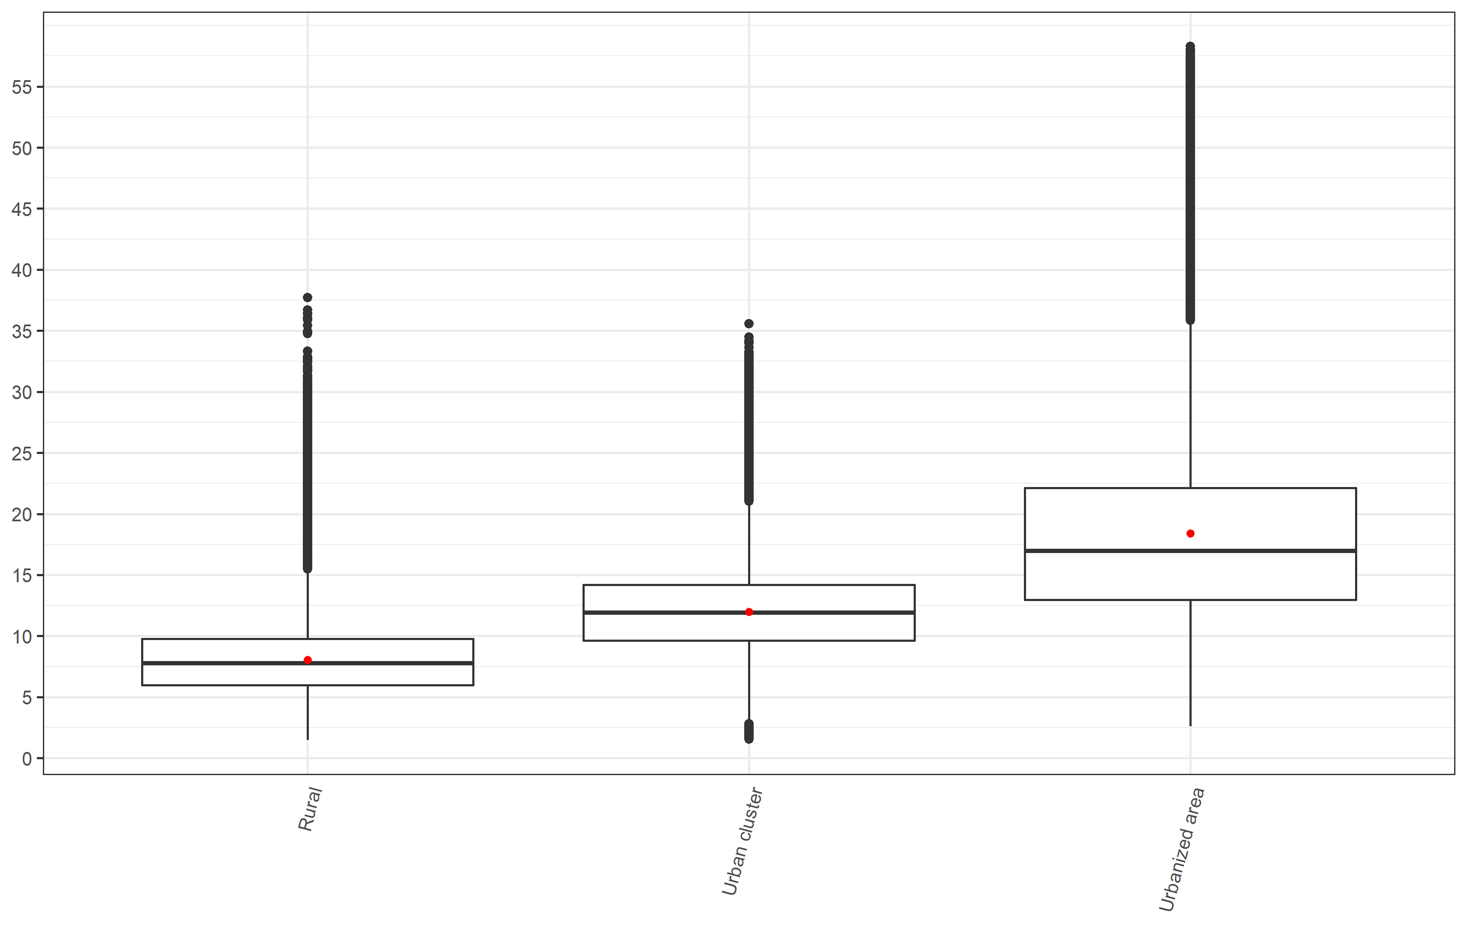

*\*Red dot represents the mean value while the midline represents the median value*

Figure S2: NO2 concentration (ug/m3) by median household income group

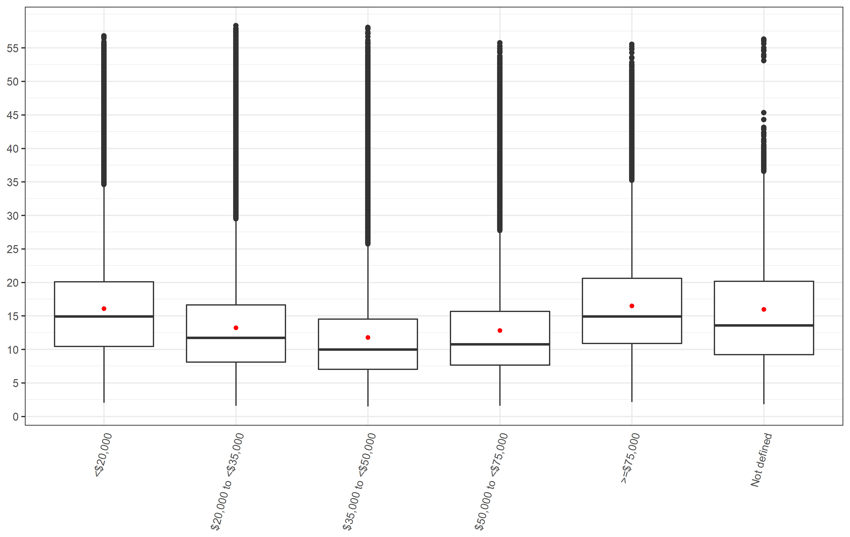

Figure S3: NO2 concentration (ug/m3) by living location stratified into median household income group

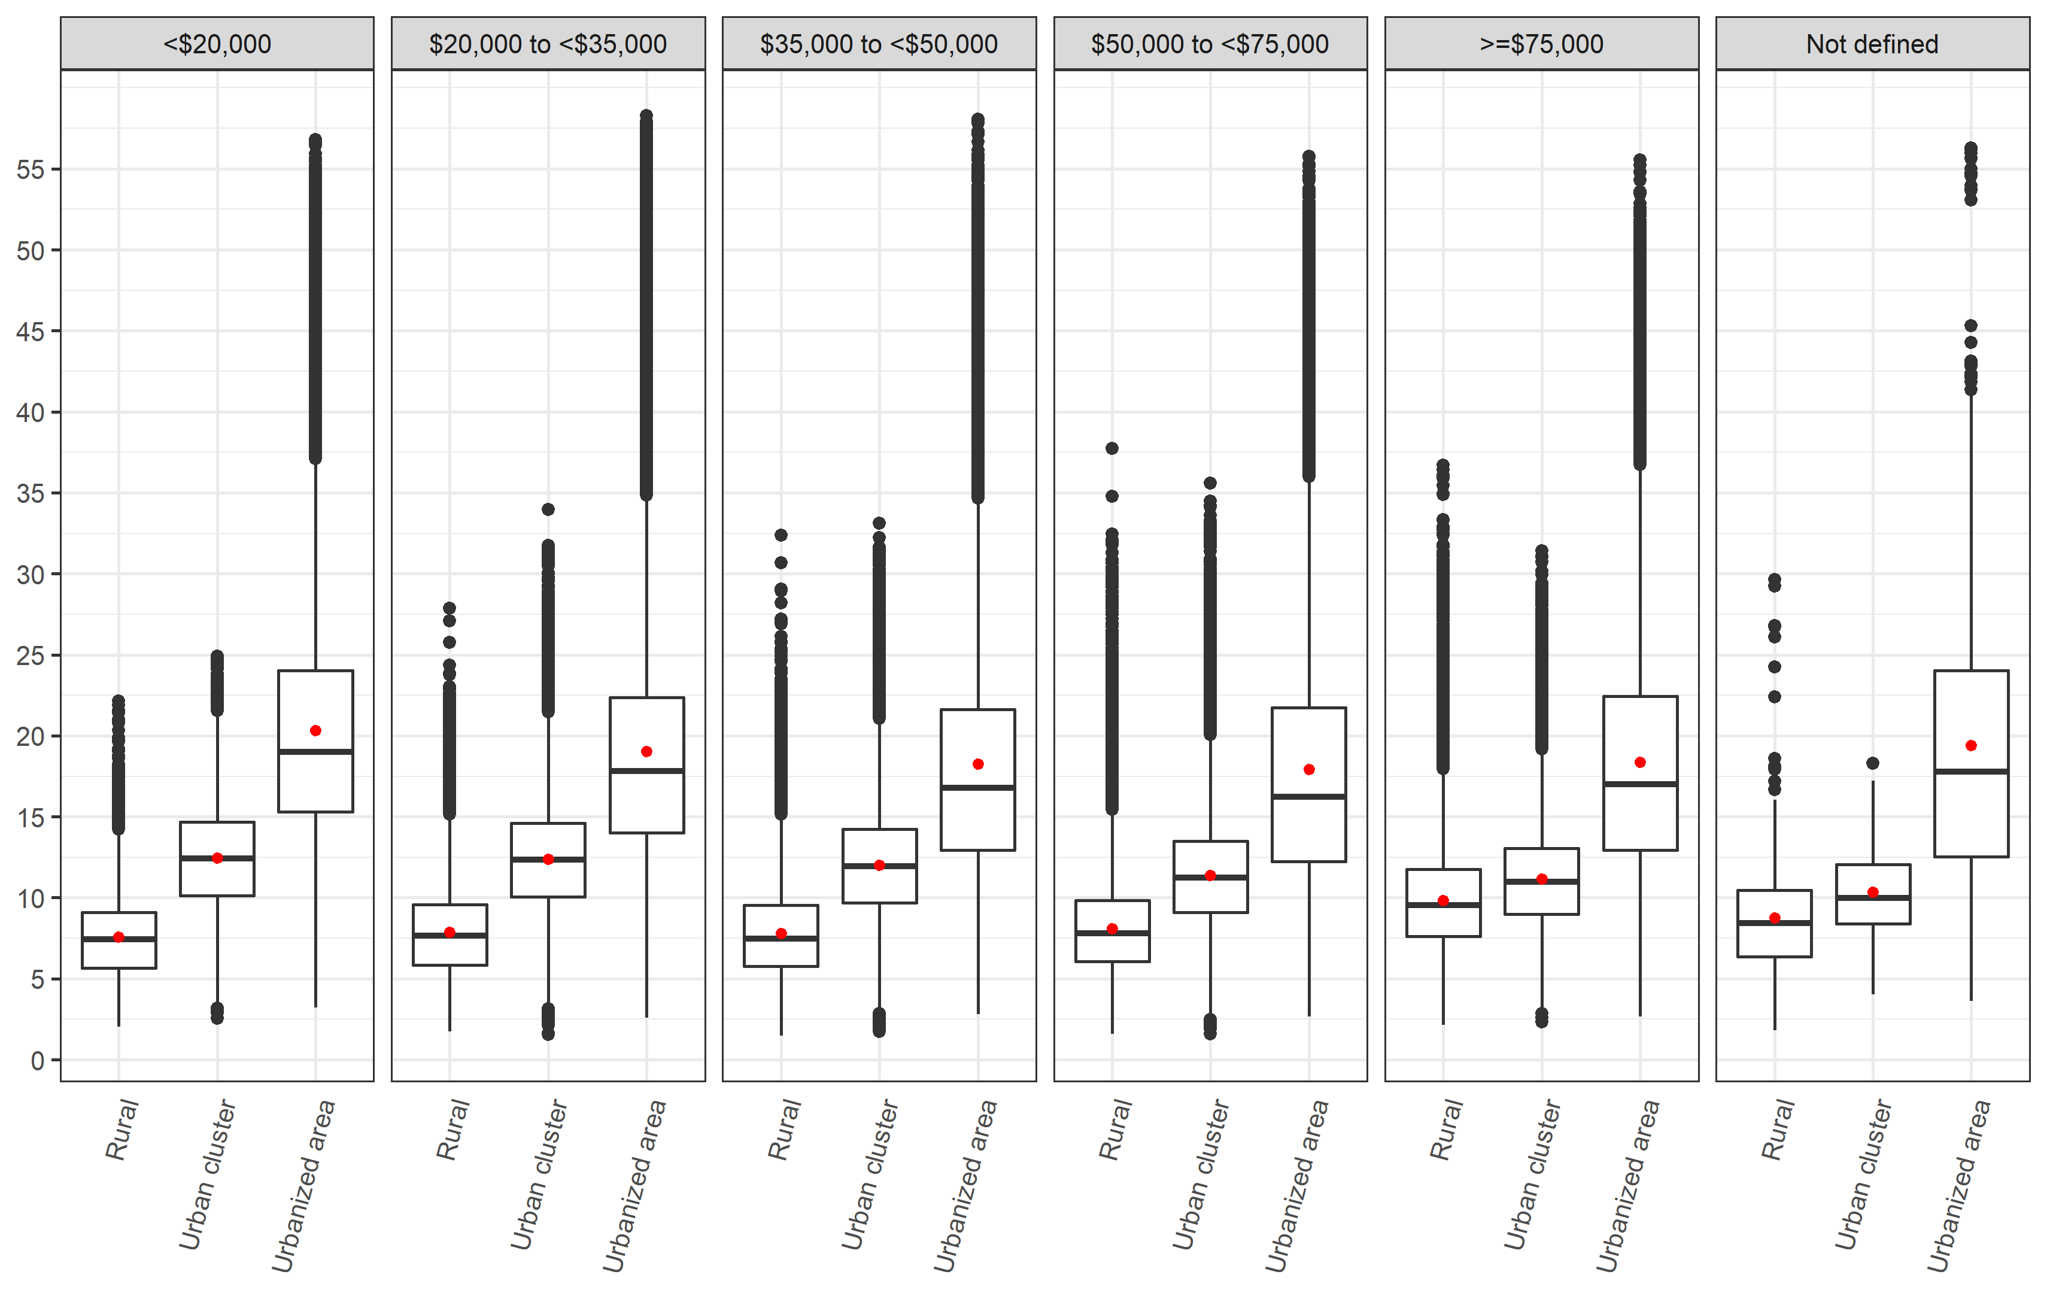

Figure S4: NO2 concentration (ug/m3) by median household income group stratified into living location

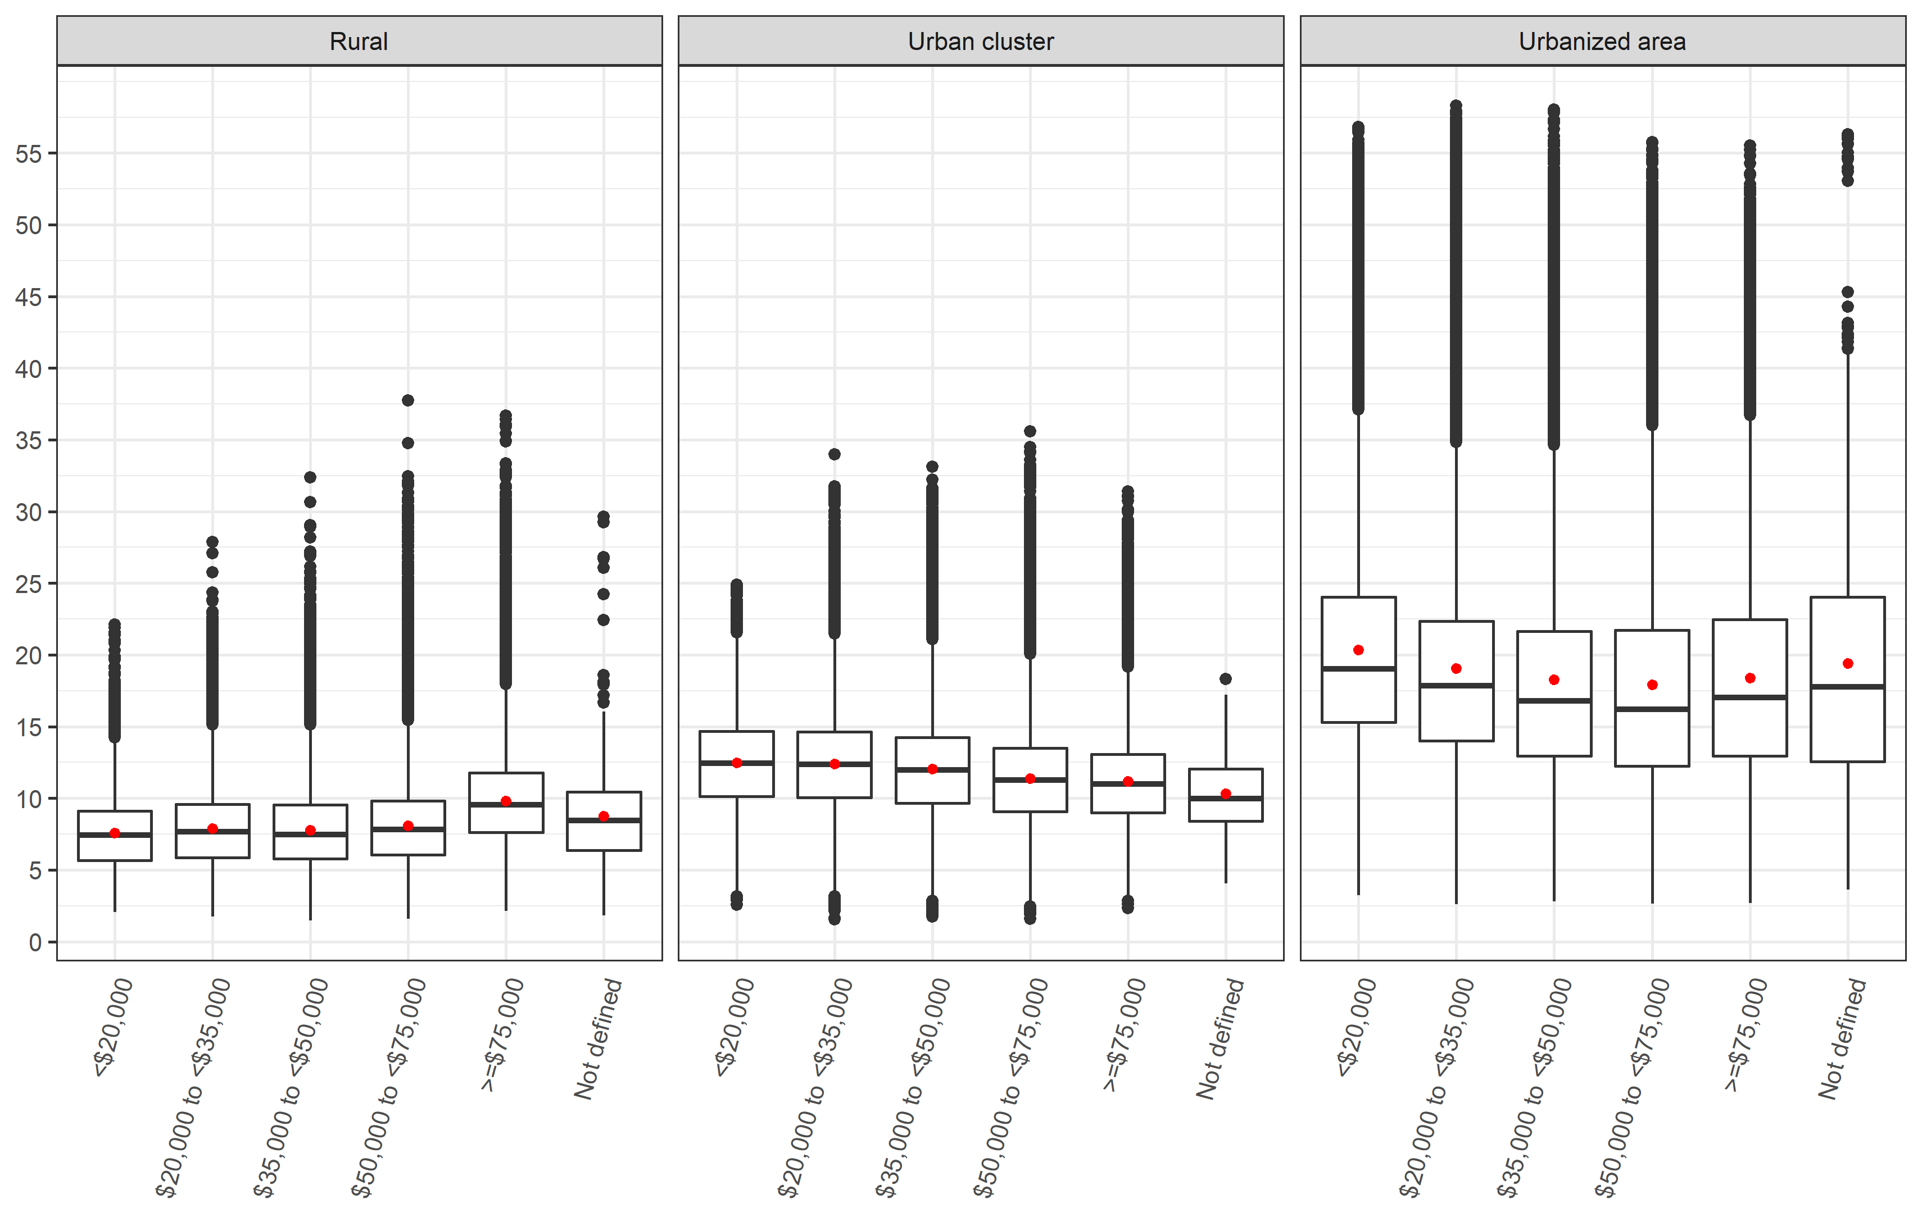

Figure S5: NO2 concentration (ug/m3) by state

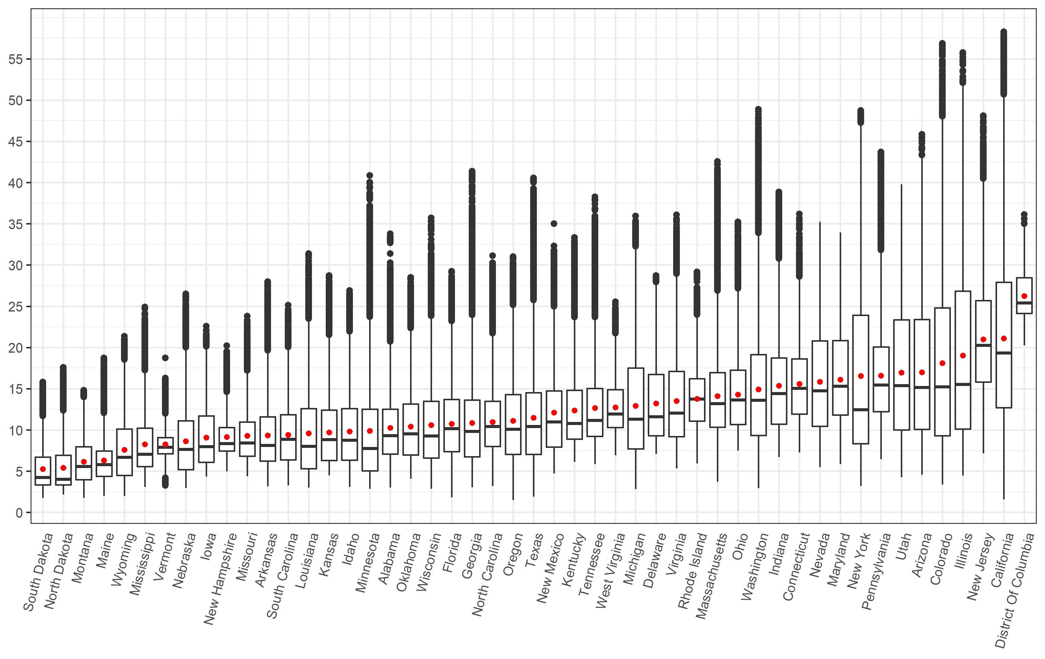

Figure S6: NO2 concentration (ug/m3) by state and median household income group

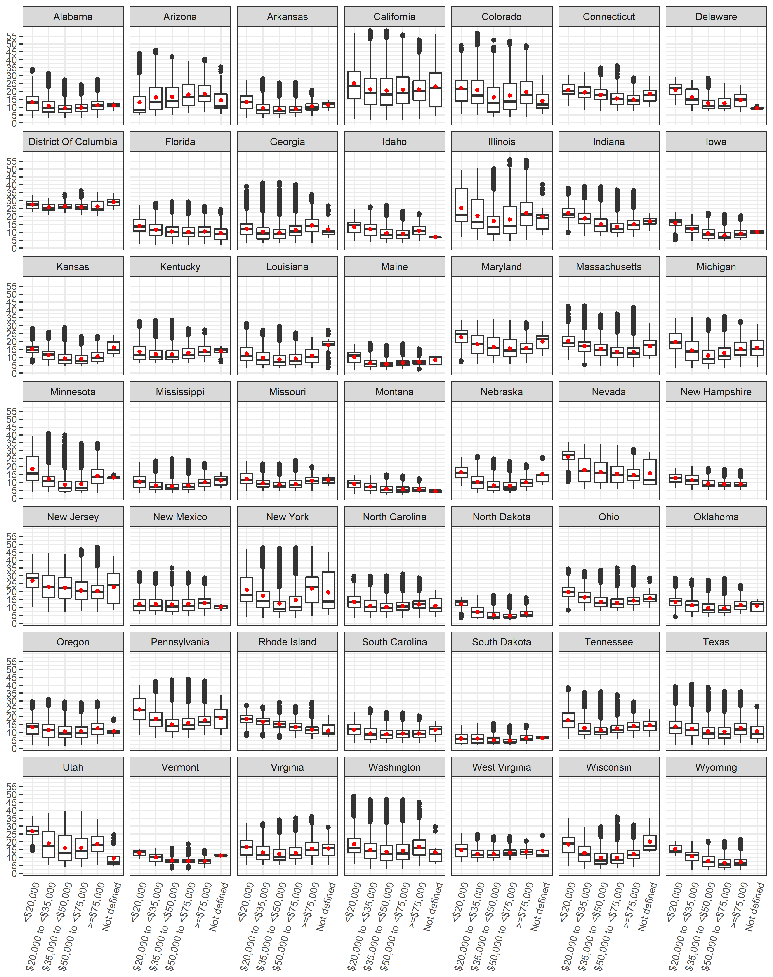

Figure S7: NO2 concentration (ug/m3) by state and living location

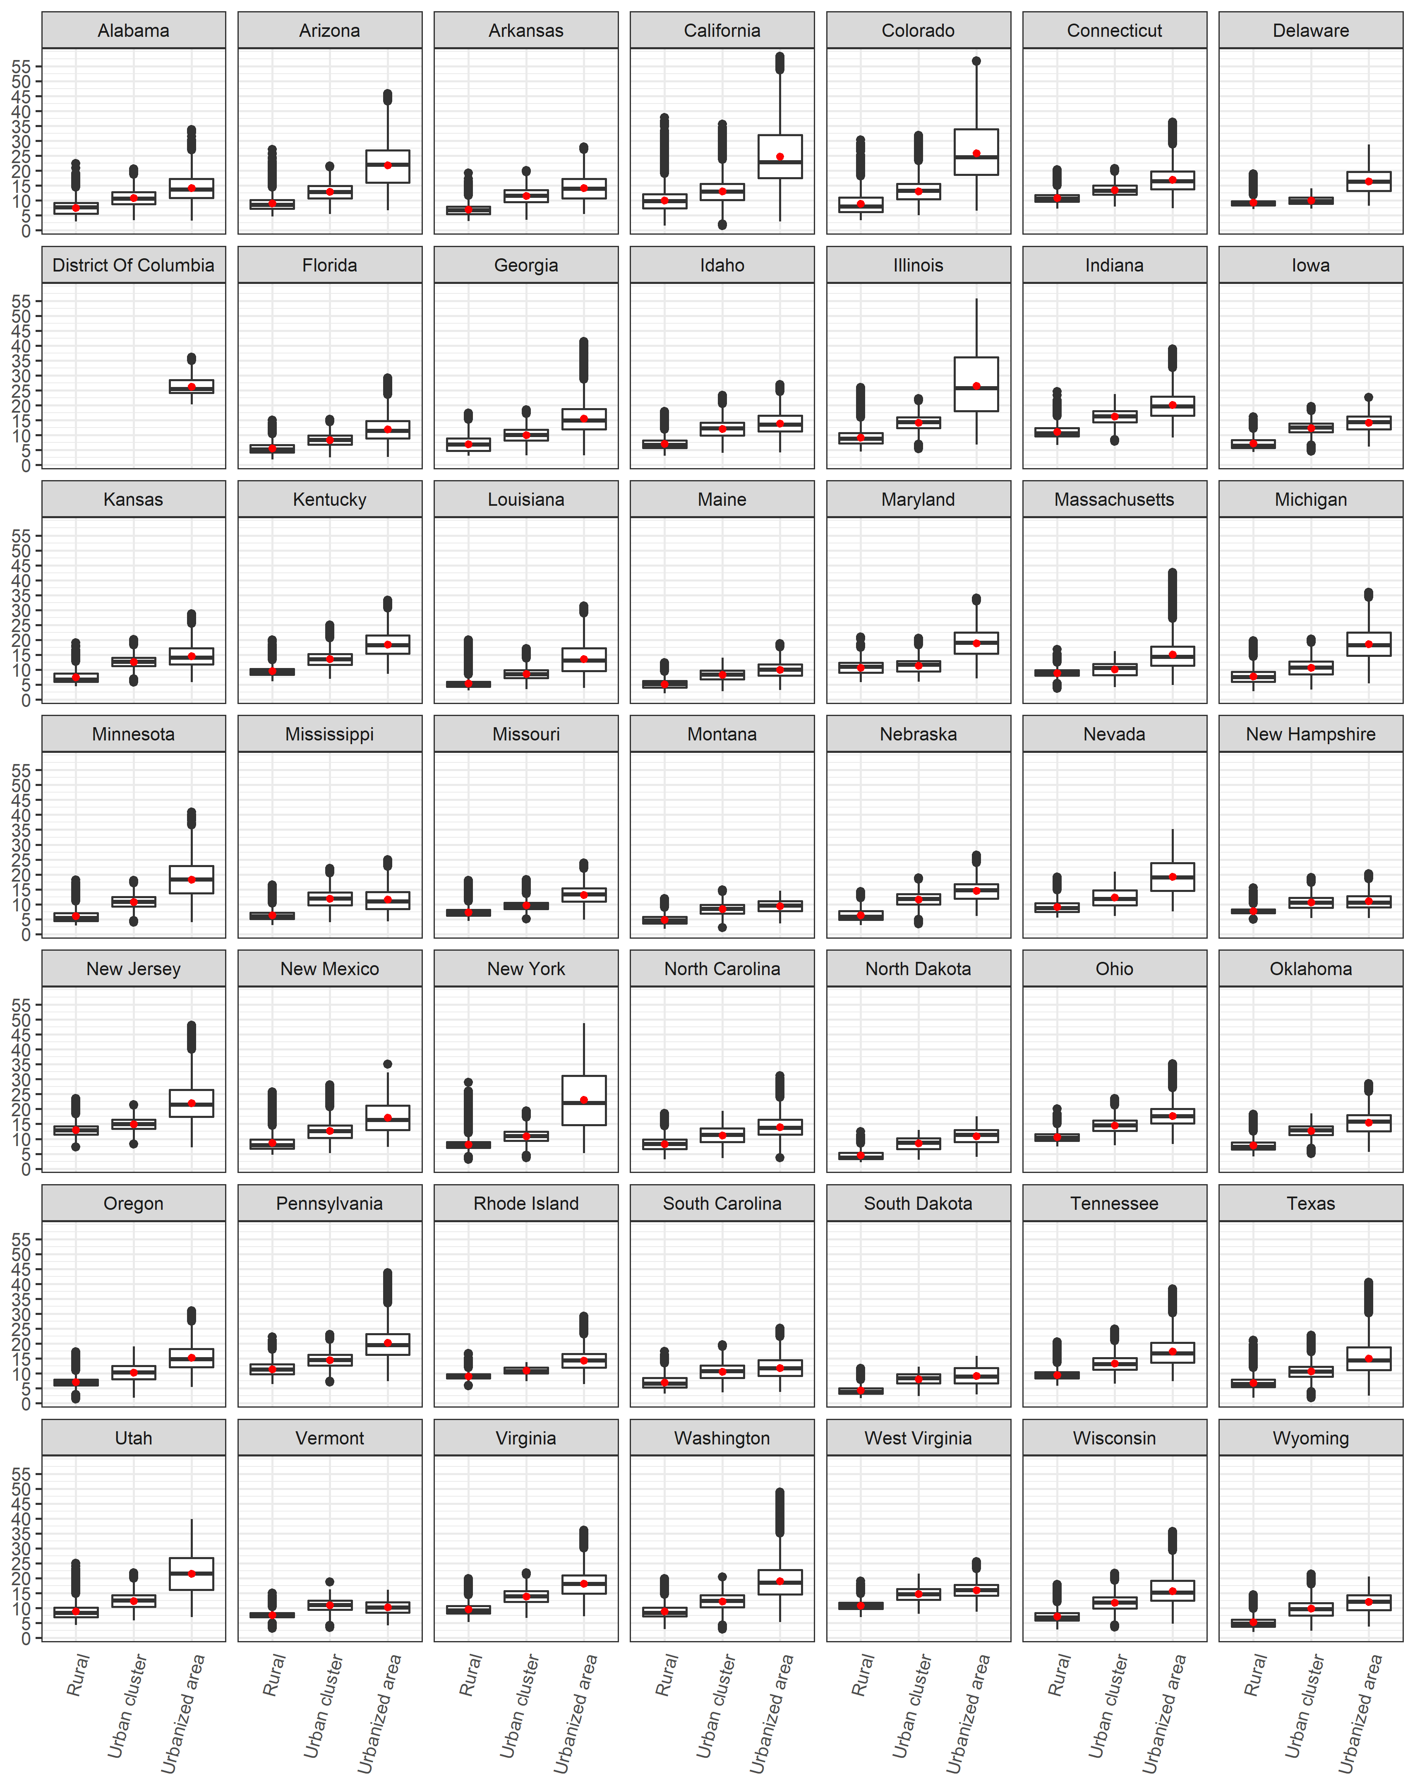

Figure S8: Attributable Fraction by living location

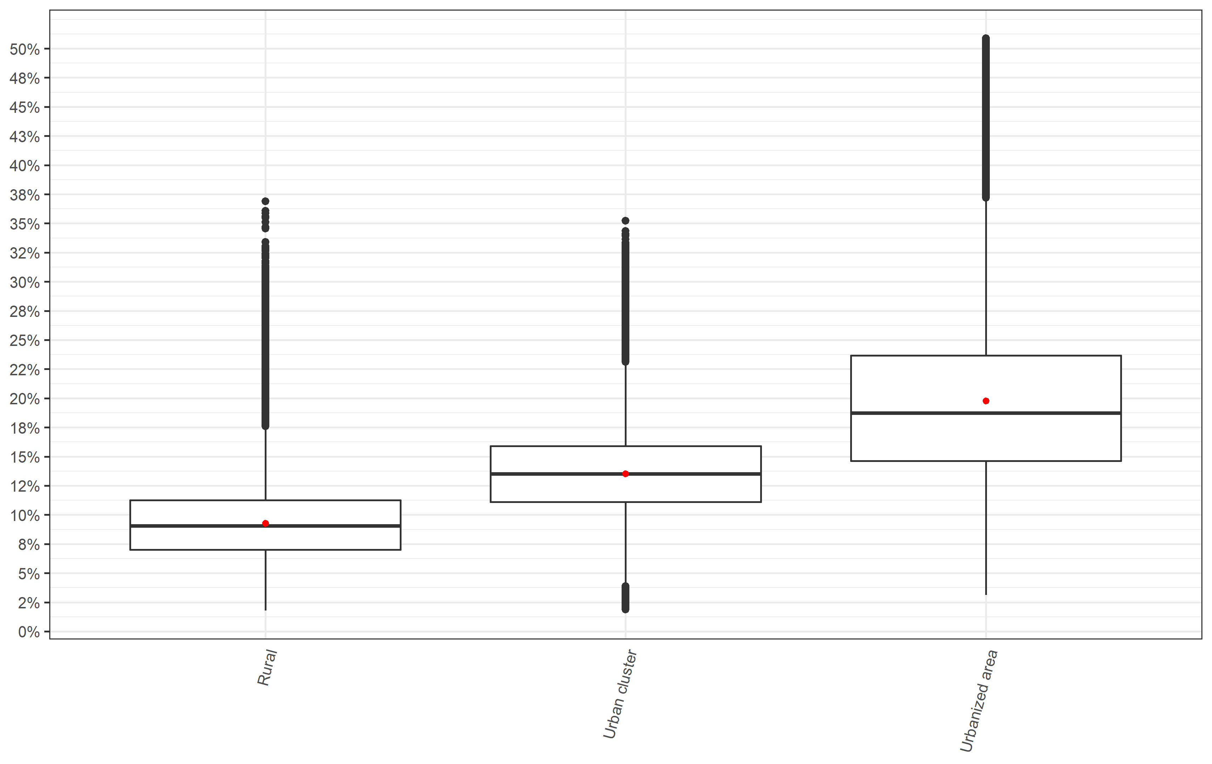

Figure S9: Attributable Fraction by median household income group

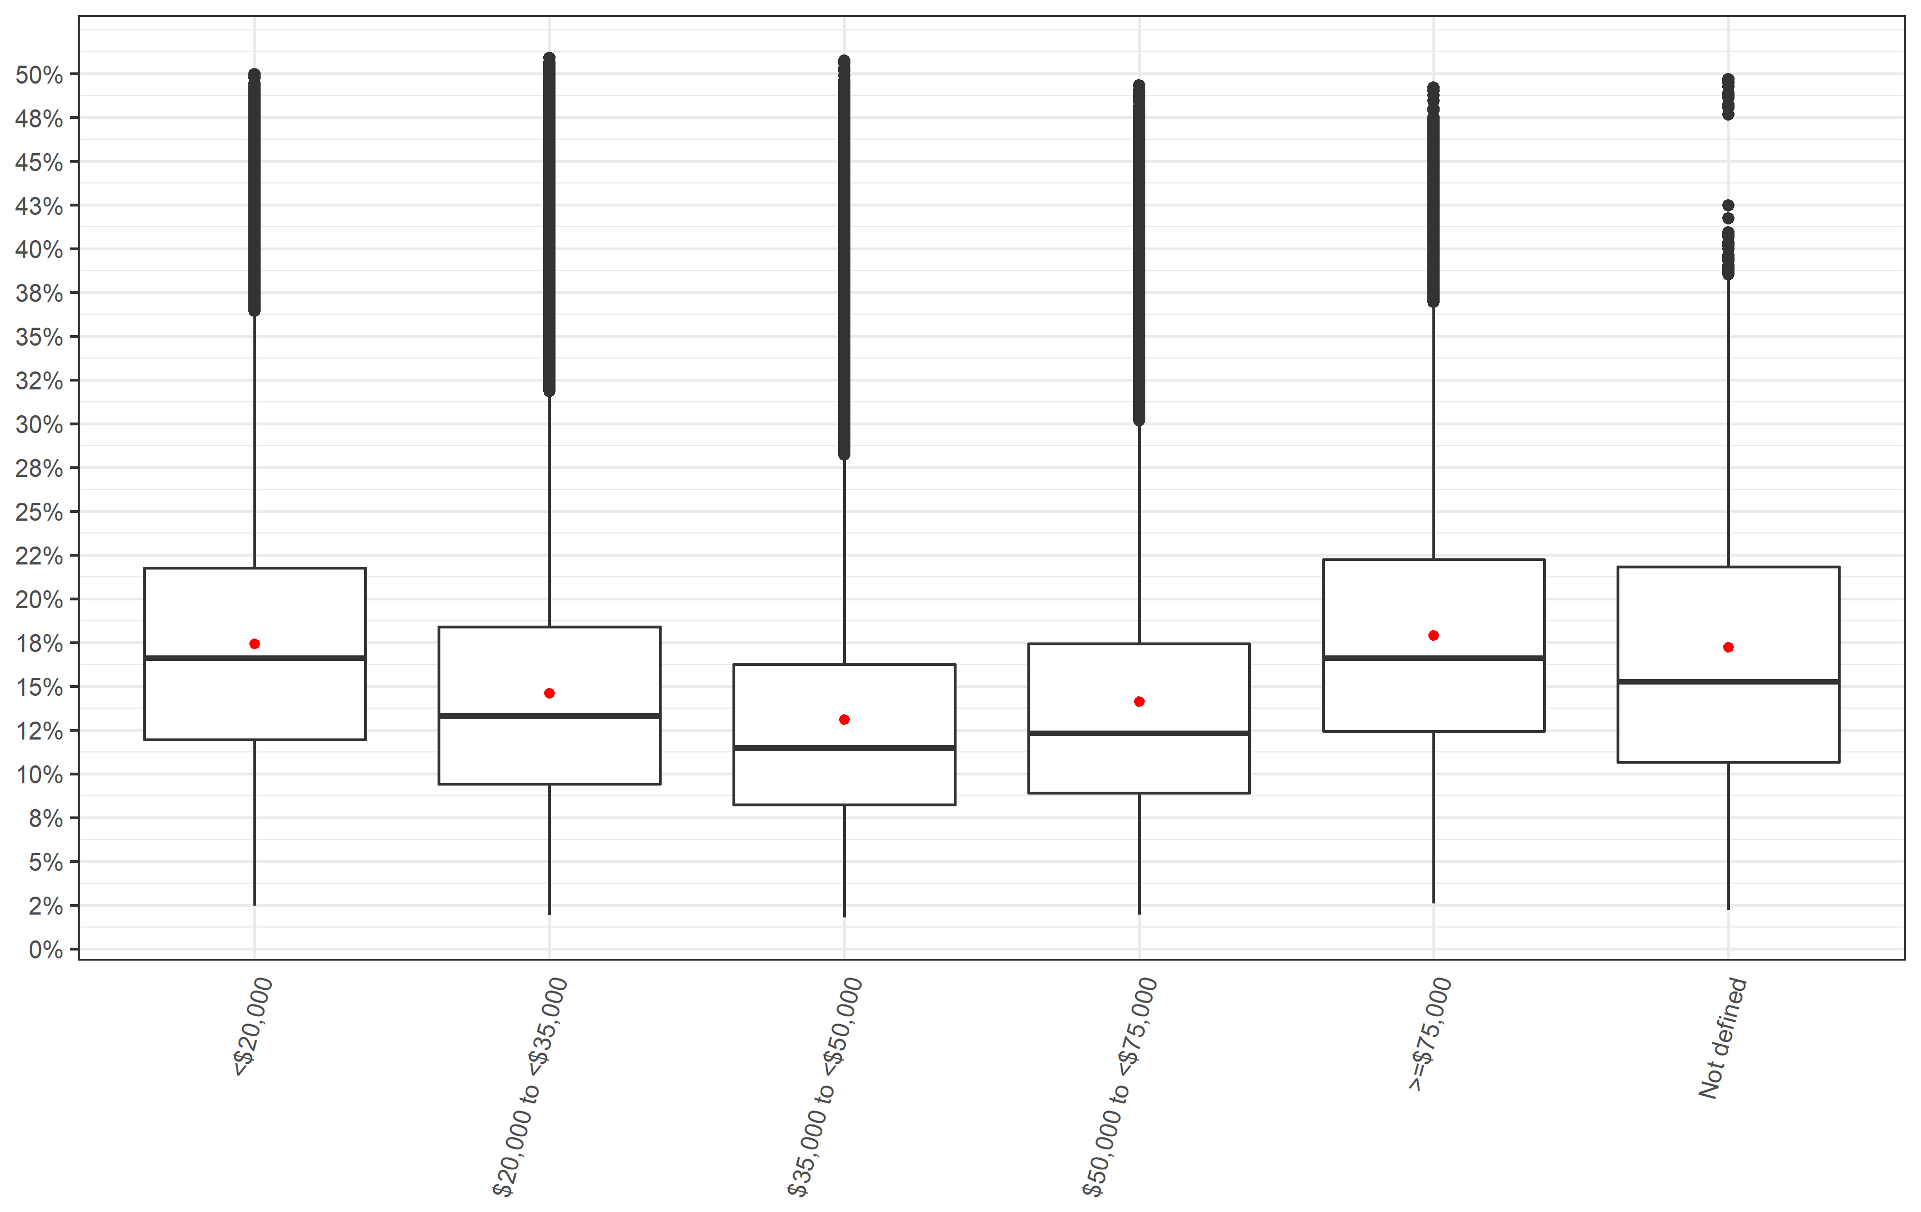

Figure S10: Attributable Fraction by median household income group stratified into living location

